

**Application Containerization**

**Experiment -4**

**NAME- Rithik Choudhary**

**SAP ID- 500069261**

**ROLL NO- R171218084**

**COURSE- B.TECH[CSE-DEVOPS]**

**SUBJEC T- APPLICATION CONTAINERIZATION LAB**

SUBMITTED TO:-

MR. HITESH KUMAR SHARMA

Docker images

Step-1

create a Dockerfile with this code

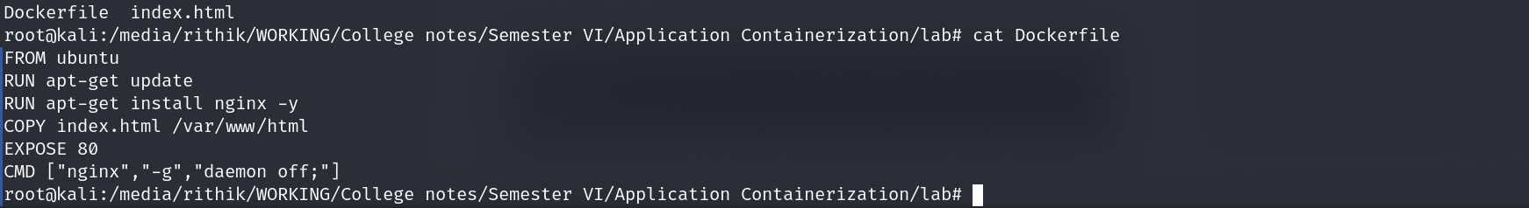

then create a index.html file which will later copy to *var/*www/html

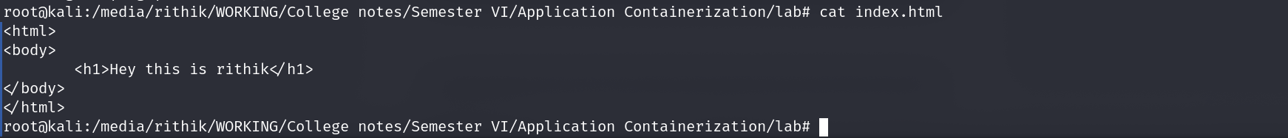

Step-2

Now build the dockerfile and it will fetch the ubuntu image from the dockerhub

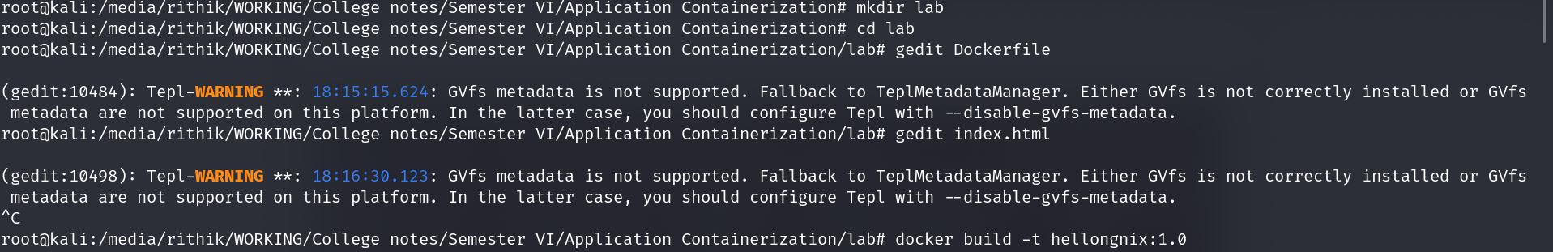

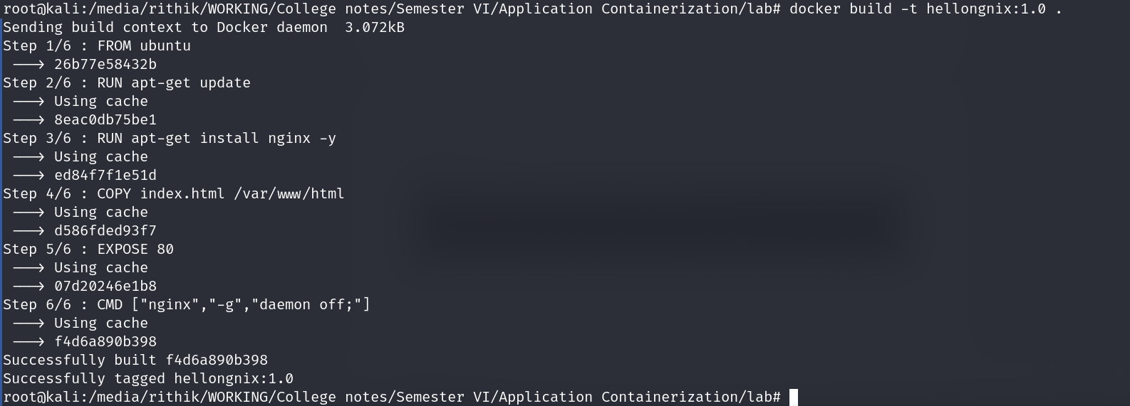

Step -3

Now check the Dockerfile run successfully and fetch the image in hellonginx:0.1

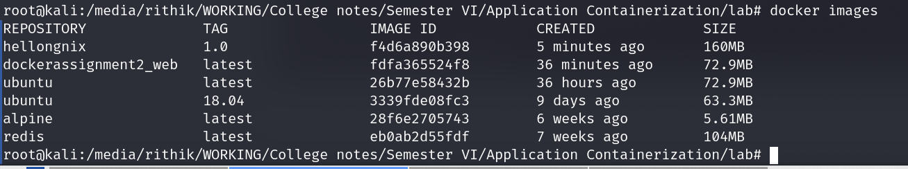

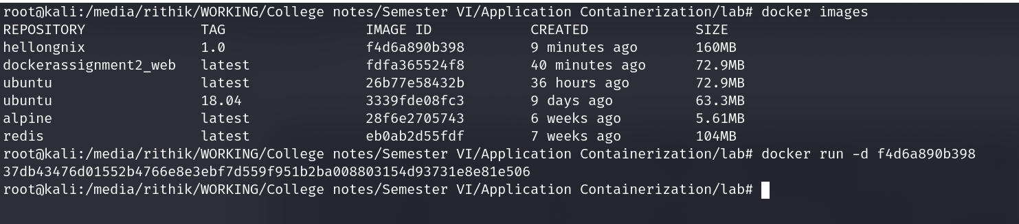

Step 3-

Now push the image on the dockerhub

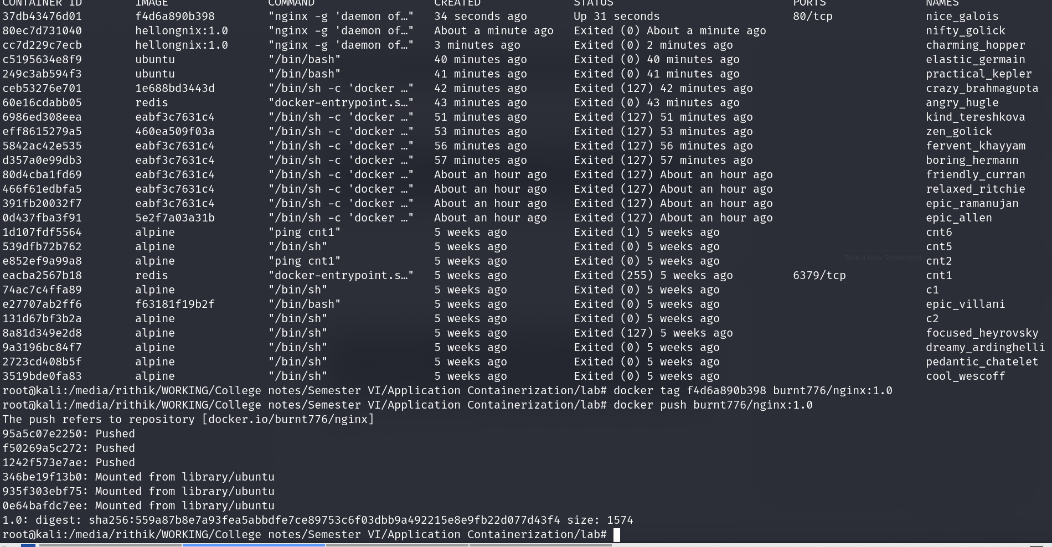

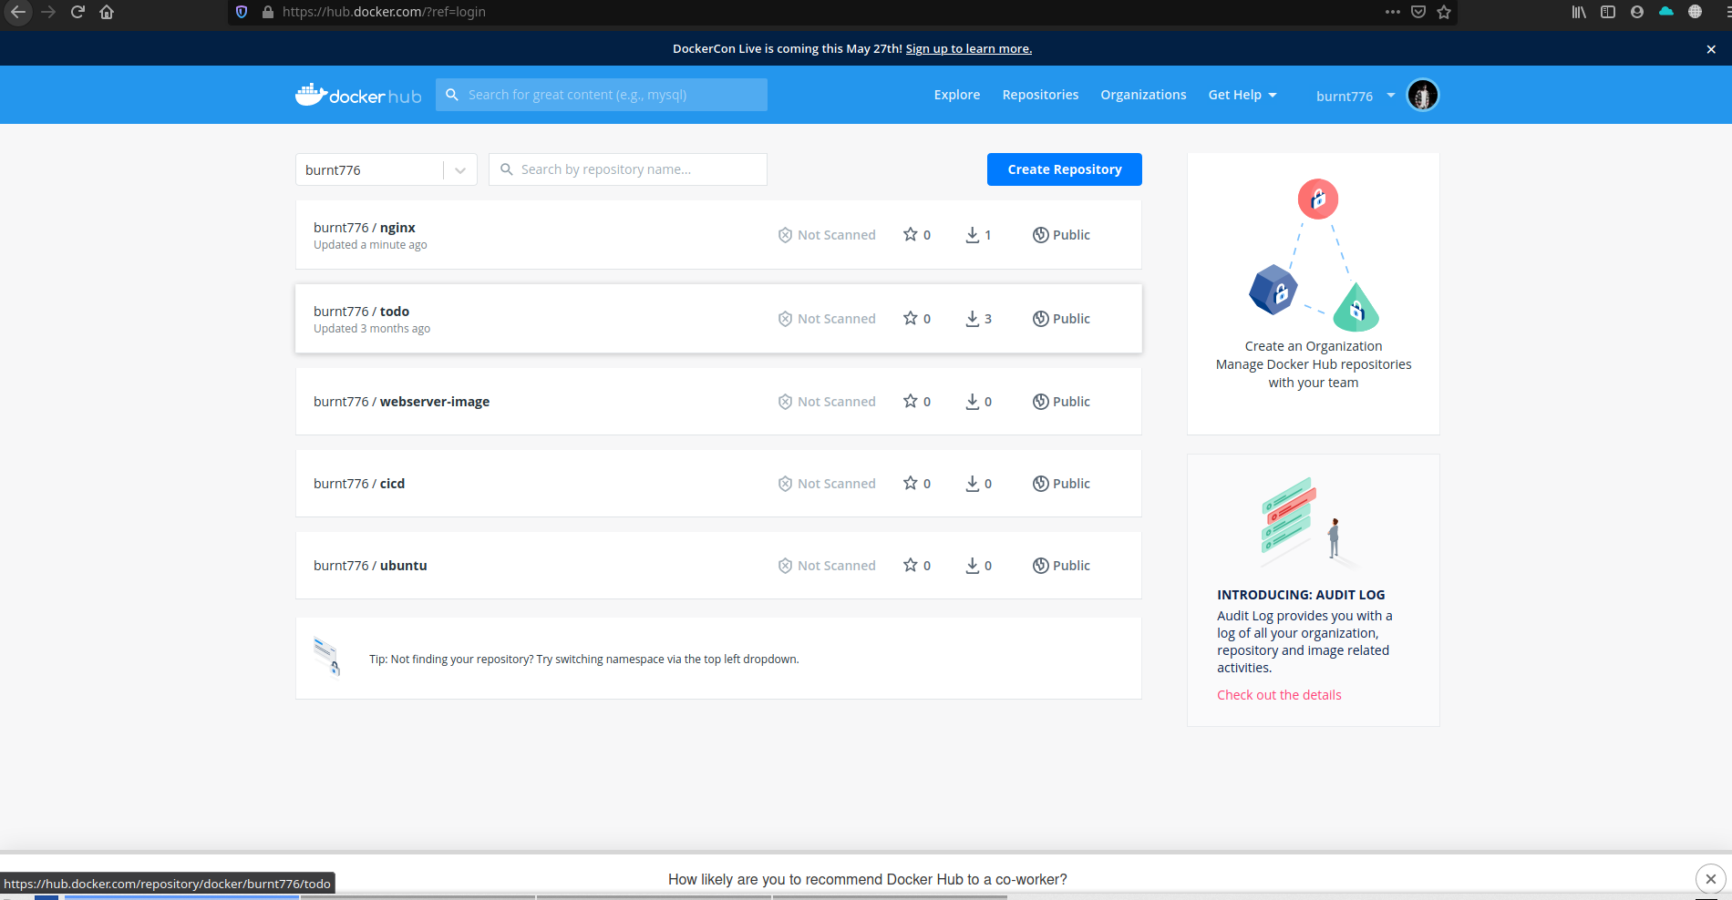

Step -4

Now run the index.html file from nginx

